
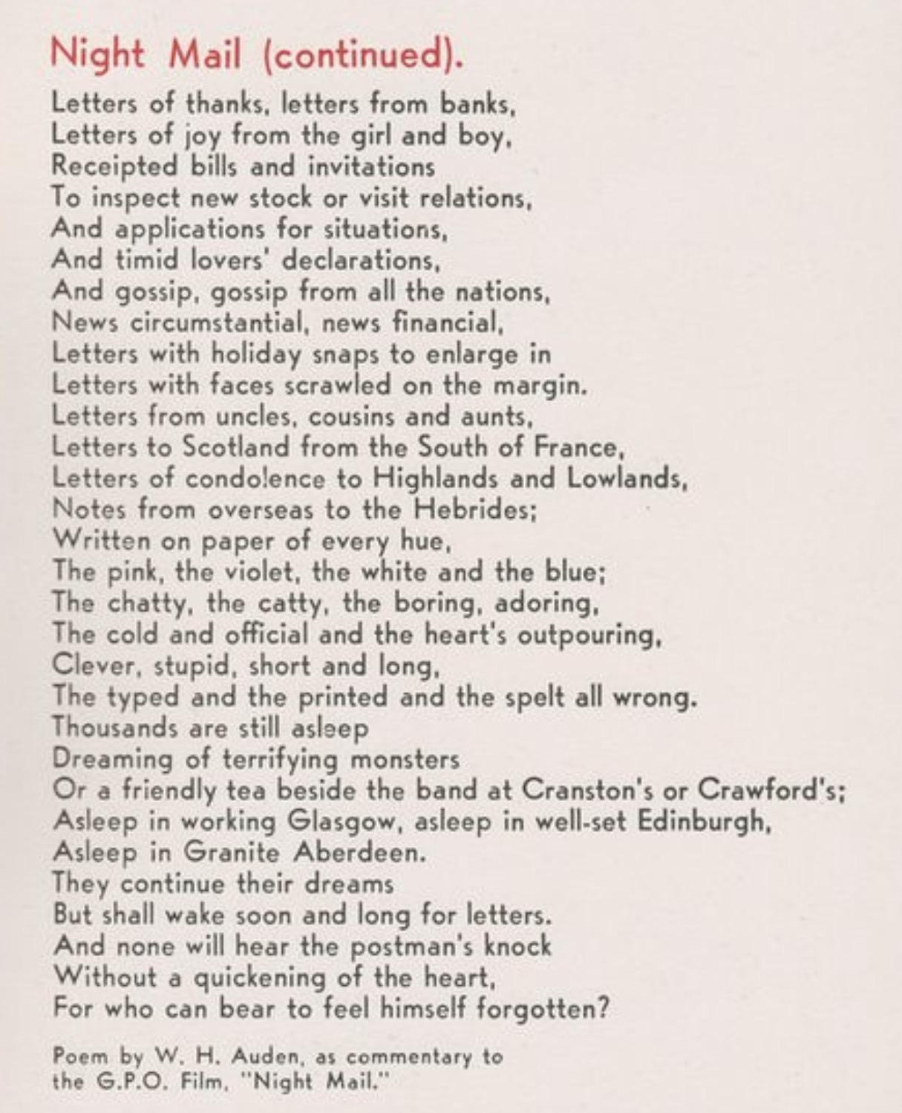
Glossary:
Beattock - a village in Dumfries and Galloway, Scotland
Gradient - an inclined part of a road or railway; a slope.
Moorland - an extensive area of open uncultivated upland.
Boulder - a large rock, typically one that has been worn smooth by erosion.
Shovel - put or push somewhere quickly and in large quantities.
Snort - make a sudden explosive sound through the nose, especially when excited or frightened.
Glasgow - Glasgow is the most populous city in Scotland, located on the banks of the River Clyde in west central Scotland.
Loch - a lake
Scrawled - write (something) in a hurried, careless way.

